The Data Scientists: Sai, Vishnu, Tyler, Ben

Premier League Table Predictor

Introduction
The Premier League Table Predictor project aims to develop a supervised machine learning model to forecast the outcomes of future matches in the English Premier League (EPL) for the remainder of the 2025-2026 season. The core of this research is based on the hypothesis that teams with a higher Expected Goals (xG) metric over a series of matches are more likely to win future matches.This project provides significant benefits by helping to gauge outcomes for Premier League matches for a variety of stakeholders, including sports bettors, football pundits, and general fans. By shifting the focus from the actual goals scored to the quality of chances created, the model aims to provide a more robust and predictive measure of team performance. We chose xG as the main predictive factor because it accounts for situational locations of shots and types of assists, offering a deeper measure of attacking performance that is less susceptible to "luck" or deflection than simply relying on final scores.The proposed method involves building a supervised machine learning model, such as a Random Forest Classifier, trained on historical team performance data to predict the binary outcome of future matches (Win, Loss, or Draw). The model's accuracy will be validated against known results from past seasons before being deployed to predict the remaining fixtures of the current 2025-2026 season.

Data Description
The data for this project was sourced from FBRef.com and consists of two team-level summary datasets capturing Premier League performance metrics at different points in time. These datasets are used for training and testing our supervised machine learning model.

Data Cleaning and Standardization
The raw data was processed by removing the unnecessary 'Rk' (Rank) column and standardizing several column names for clarity: Squad remained unchanged, MP became Matches_Played, Pts/MP became Points_Per_Match, and xGD/90 became xGD_Per_90.

Dataset Name | Matches Played (MP) | Role | File Origin
Nov dataset | 12 | Training Data | fbref_data_nov_26
Dec dataset | 13 | Test Data | fbref_data_dec_1

Feature Descriptions
The primary metrics selected for the model, which reflect a team's attacking strength, defensive stability, and overall quality, are detailed below. Our hypothesis heavily relies on the Expected Goals (xG) related metrics.

Column Name | Data Type | Description
Team | object | The name of the Premier League club.
Matches_Played | int64 | The total number of matches played up to that date.
W, D, L | int64 | Number of Wins, Draws, and Losses.
GF, GA | int64 | Goals For (Scored) and Goals Against (Conceded).
GD | int64 | Goal Difference ($\text{GF} - \text{GA}$).
Pts | int64 | Total Points Accumulated (3 for a win, 1 for a draw).
Points_Per_Match | float64 | Average points earned per match.
xG, xGA | float64 | Expected Goals For and Expected Goals Against. This is a measure of offensive and defensive performance, based on the quality of chances created and conceded.
xGD | float64 | Expected Goal Difference ($\text{xG} - \text{xGA}$). This is a key predictor, indicating a team's expected net performance.
xGD_Per_90 | float64 | Expected Goal Difference per 90 minutes.
Nov Dataset (Test data) head:
 | Team | Matches_Played | W | D | L | GF | GA | GD | Pts | Points_Per_Match | xG | xGA | xGD | xGD_Per_90
0 | Arsenal | 12 | 9 | 2 | 1 | 24 | 6 | 18 | 29 | 2.42 | 20.7 | 6.1 | 14.6 | 1.22
1 | Chelsea | 12 | 7 | 2 | 3 | 23 | 11 | 12 | 23 | 1.92 | 22.1 | 13.9 | 8.2 | 0.69
2 | Manchester City | 12 | 7 | 1 | 4 | 24 | 10 | 14 | 22 | 1.83 | 21.8 | 12.6 | 9.2 | 0.76

Dec Dataset (Test Data) head:

 | Team | Matches_Played | W | D | L | GF | GA | GD | Pts | Points_Per_Match | xG | xGA | xGD | xGD_Per_90
0 | Arsenal | 13 | 9 | 3 | 1 | 25 | 7 | 18 | 30 | 2.31 | 21.8 | 6.9 | 14.9 | 1.15
1 | Manchester City | 13 | 8 | 1 | 4 | 27 | 12 | 15 | 25 | 1.92 | 24.4 | 14.2 | 10.2 | 0.79
2 | Chelsea | 13 | 7 | 3 | 3 | 24 | 12 | 12 | 24 | 1.85 | 22.9 | 14.9 | 8.0 | 0.61

Methodology
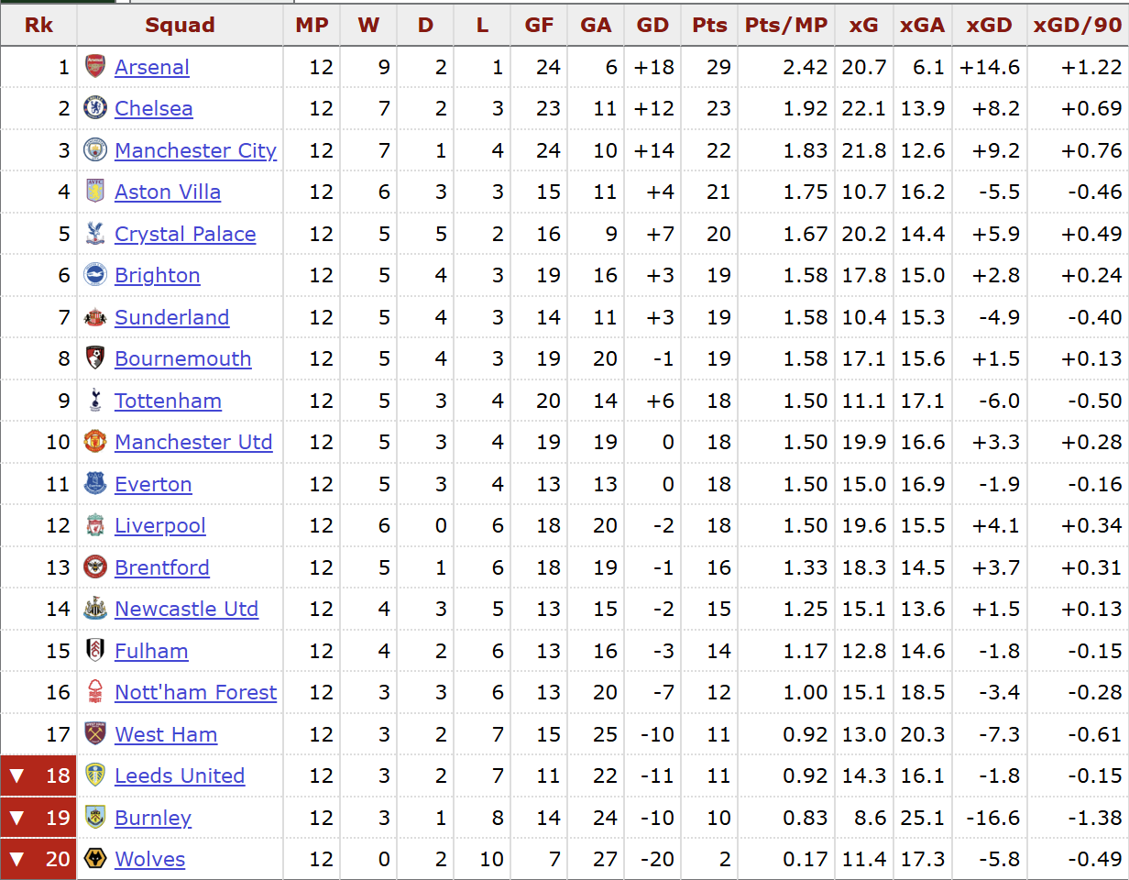
For our methodology, we created and trained a Random-Forest Regression machine learning model using supervised learning to predict the number of points each team in the Premier League is likely to have after their next round of matches played. We therefore trained the model on the data from the November 26th dataset, when every team had already played 12 matches, and then used it to predict the point totals of each team after they played their 13th matches based on the following features:
- Goals for (GF)
- Goal differential (GD)
- Points per match played (Pts/MP)
- Expected goals (xG)
- Expected goal differential (xGD)
- Expected goal differential over 90 minutes played (xGD/90)

We then tested these initial predictions against the actual point values from the December 1 dataset, after every team had played their 13th match, to determine the prediction accuracy of the model. To represent this, we calculated the coefficient of determination to be R² = 0.89, where an R² closer to the maximum value of 1.0 is more accurate. We also calculated the mean absolute error (MAE) of the model to be 1.72, where a lower MAE indicates better model performance, as it reflects smaller average errors in predictions.
- Formula for coefficient of determination: R² = 1 - (SSres / SStot)
- Where: SSres is the sum of squares of the residual errors. SStot is the total sum of squares of the errors.

Results
Using the methodology described above, our Random Forest regressor achieved an R² of 0.89 and a Mean Absolute Error (MAE) of 1.72 on the December 1 dataset (after each team’s 13th match). In practical terms, this means the model’s predictions for each team’s point total are, on average, within a little over half of a win (three points) of the actual value, which is quite strong for a forecast.
The feature importance analysis (Figure X) shows that the model relies most heavily on Points per Match (Pts/MP) and Goal Difference (GD) when generating predictions. These two features dominate the importance ranking, indicating that short-term projections are driven primarily by teams’ recent performance and scoring margins. The expected goals based features (xG, xGD, xGD/90) still contribute, but to a lesser degree. This partially contradicts our original expectation that expected goals metrics would be the main drivers. Instead, they act as secondary refinements layered on.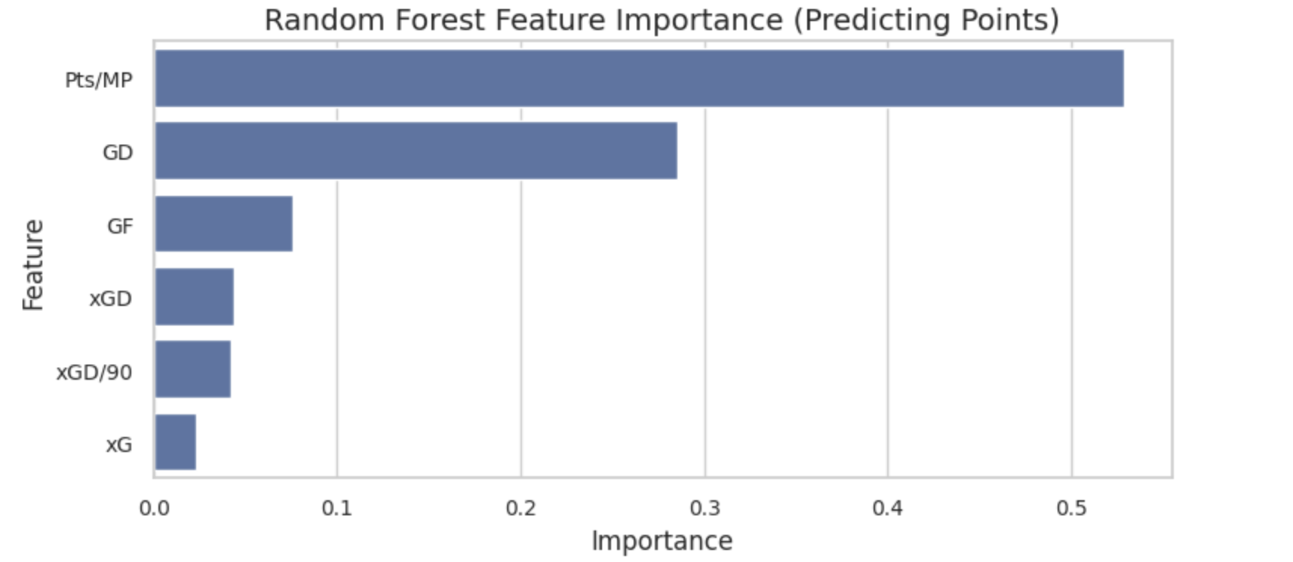
Figure X – Random Forest Feature Importance

We also used the trained model to generate a projected table after 14 matches (Figure Y). The projection keeps strong teams such as Arsenal and Manchester City near the top of the table, while placing several mid-table teams in a tightly clustered band of predicted points. This clustering reflects areas where the model cannot clearly separate teams based on the available features, which is useful information for stakeholders.
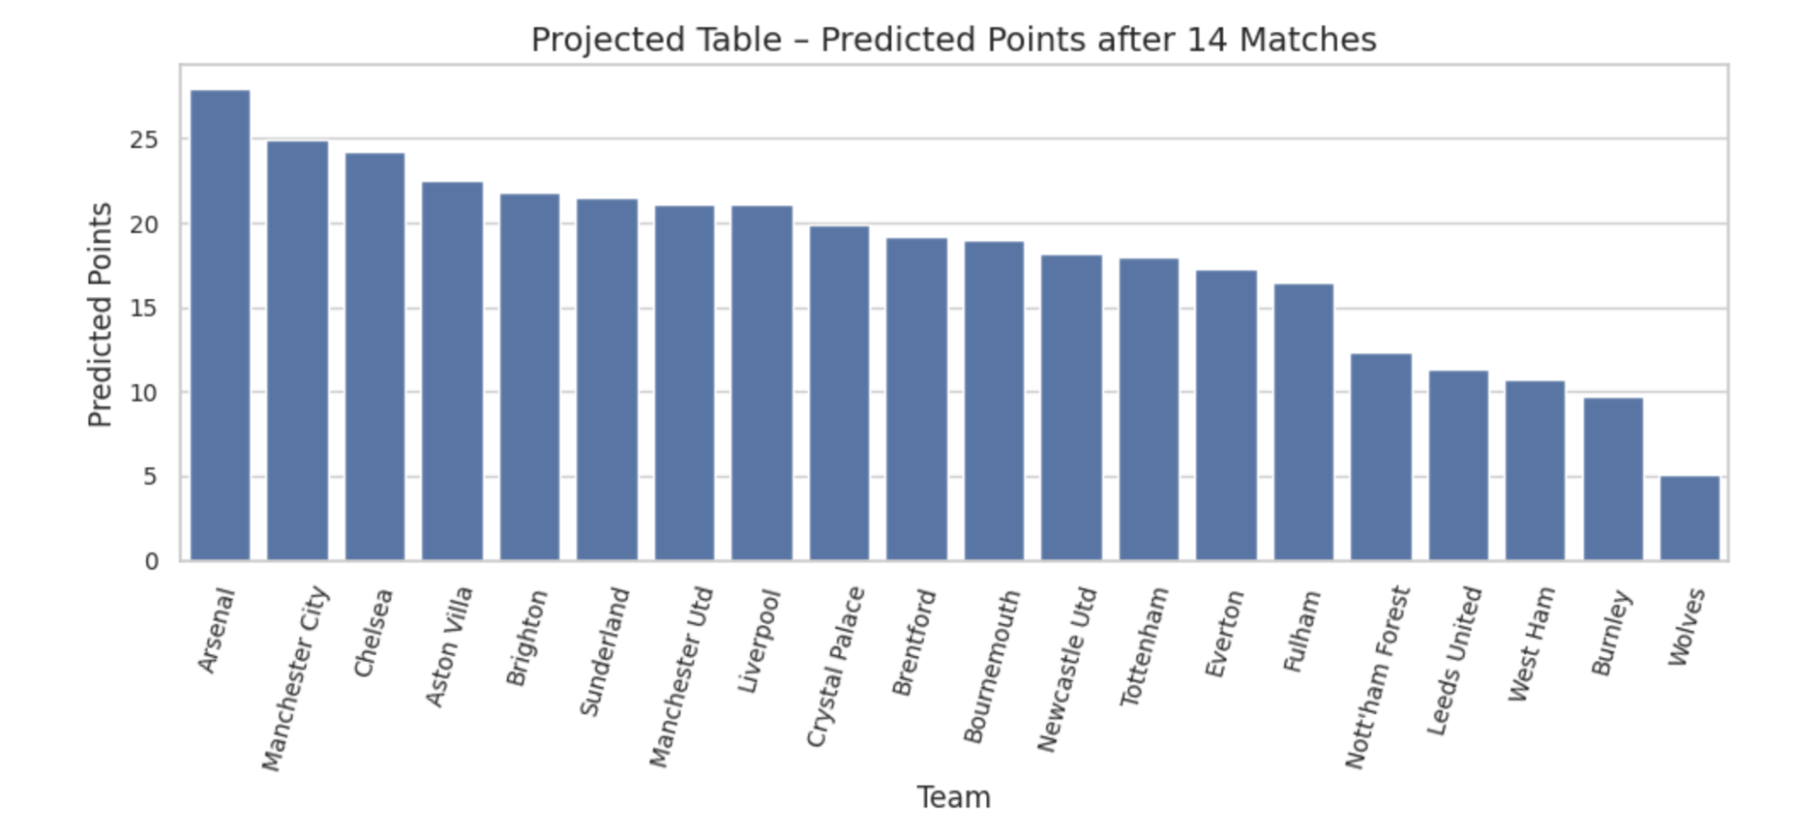
Figure Y – Projected Table (Predicted Points after 14 Matches)

Conclusion
The aim of our project was to determine the presence or the absence of the relation between the level of the team-level performance indicators, specifically, xG based statistics and the short-term performance within EPL (Premier League). On this, we have made predictions of the number of points that a given club has attained at the culmination of an extra round of matches utilizing FBRef team summary data, as a result of a prepared Random Forest regression model, and contrasted the predictions with the fact. The model was also useful since it had an R2 of 0.89 and a mean absolute error of 1.72 points which means that anything that a team had in regard to the total numbers of points could be predicted with an accuracy although the size of the data was very small.
Although the first hypothesis led us to the direction, which believed that expected goals should be the major determinants of future performance, the outcome of the research revealed that the realization of performance indicators, the most prominent being points per match and the goal difference, were the most important characteristics in predicting short-term points. Some of the variables of some objectives like xG, xGD or xGD/90min were also expected to convey much information, but, they were to be refined rather than be the dominating ones. It is because in the prognostic horizons of a short term; more emphasis is put on the recent physical performance but xG-based variables will take the pre-eminence in the long-term or a more form-adjusted model. The findings can also be supported by the fact that the model simulated league table implies that the best teams like the Arsenal and the Manchester city are always ahead with the other mid table team that is near the bottom being near. Such grouping shows the inherent inertia of grouping the teams of similar statistical natures which possess less than handfuls of snapshots of the information and the obscurities of the situation of the competition of the middle-table teams.
Although there is a good performance, there are certain limitations, which are associated with the project. The sample size (2 sets of time only) is exceedingly too small and manually done, which could have been biased and limiting to generalizations. In addition to this, the model fails to show the contextual problems like the home-field advantage, the problem of schedules, injury or congestion of players during a match. It would be further applied in the future to extrapolate the data to other seasons, and would learn match-level and context-based variables and time series or rolling-window forecasts to learn more long-run dynamics of team building and performance. In general, this project indicates that machine learning models will be used to establish the short term predictions regarding the number of points in the premier league in the light of the metrics associated with the performance of the team. While expected goals metrics do give useful insight on underlying team quality, recent realized performance appears to be more influential for immediate predictions, with xG-based measures serving as a complement rather than a replacement for traditional performance indicators

Appendix:
Q: What is a Random Forest, and how does it differ from a single decision tree in terms of prediction and variance reduction?
A: A Random-Forest Regressor is a machine learning technique used for predicting numerical values such as Premier League point totals. It works by building many decision trees (hundreds or even thousands) and averages their predictions to produce a final regression output, which, in comparison to a single decision tree, is much more stable and improves performance by reducing variance.
Q: What is R² and why is R² the appropriate choice here?
A: R² is a statistical metric that measures how well a regression model explains the variability in the target variable. It is widely used for evaluating regression models—including Random-Forest Regressors—because it shows how much of the variation in the true values the model can predict.
Q: How balanced is your dataset? Are some teams harder to predict than others due to small sample size?
A: Our dataset is structurally balanced in the sense that every Premier League team appears once per snapshot and has played the same number of matches (12 in the training set and 13 in the test set), but it is very small overall (only 20 teams). In practice, teams with very similar stats, especially clustered mid-table sides, are harder to distinguish, while clear top and bottom teams are easier for the model to predict.
Q: How did you compute feature importance in a Random Forest regressor—what does it measure and how should it be interpreted?
A: We used scikit-learn’s default impurity-based feature importance, which measures how much each feature reduces prediction error (mean squared error). A higher importance score means that splits on that feature contribute more to improving the model’s predictions, but it should be interpreted as a relative influence on the model’s decisions, not as a direct causal effect.
Q. What future improvements would you make—more features, expanded dataset, or exploring time-series forecasting methods?
A: Our next steps would be to expand the dataset to include multiple seasons and game data, add richer features (home/away splits, strength of schedule, injuries), and move from a single-step regression to time-series approaches such as rolling-window models or forecasting methods. This would let us capture form over time, better handle schedule effects, and evaluate whether more complex models can outperform simple baseline models over longer horizons.
Q: Did manual data collection introduce any bias or inconsistency, and how might you prevent that moving forward?
A: The small data set as a result of manual data collection potentially made the model biased towards teams that were already at the top, as it is unlikely to predict that a team with better stats thus far would gain less points in the next week than a team at the bottom of the rankings.

References:
Premier League Stats | FBref.com
RandomForestRegressor — scikit-learn 1.7.2 documentation
r2_score — scikit-learn 1.7.0 documentation - sklearn
mean_absolute_error — scikit-learn 1.8.0 documentation

Code:
fbref_predictor_(copy).ipynb
fbref_data_nov_26
fbref_data_dec_1

